# Acceptance Criteria Testing

## Story ID 21

**User Story:**

As the driver I want to be able to record my total hours spent working, and my total hours spent driving so my shifts are recorded digitally and not prone to loss.

**Acceptance Criteria:**

* I can record my start time and the end time of my shift. This will automatically calculate how many hours I worked.
* I can view my past shifts.
* I can view my upcoming shifts.

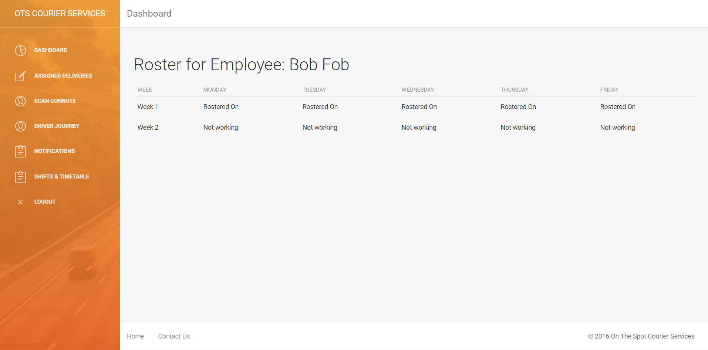

This screenshot shows the page that the driver sees when looking for their shifts. This differentiates from the criteria however as instead of tracking hours it tracks per day that you are rostered on. This version shows the shifts for a 2 week period however this could be extended to show as many weeks as required.

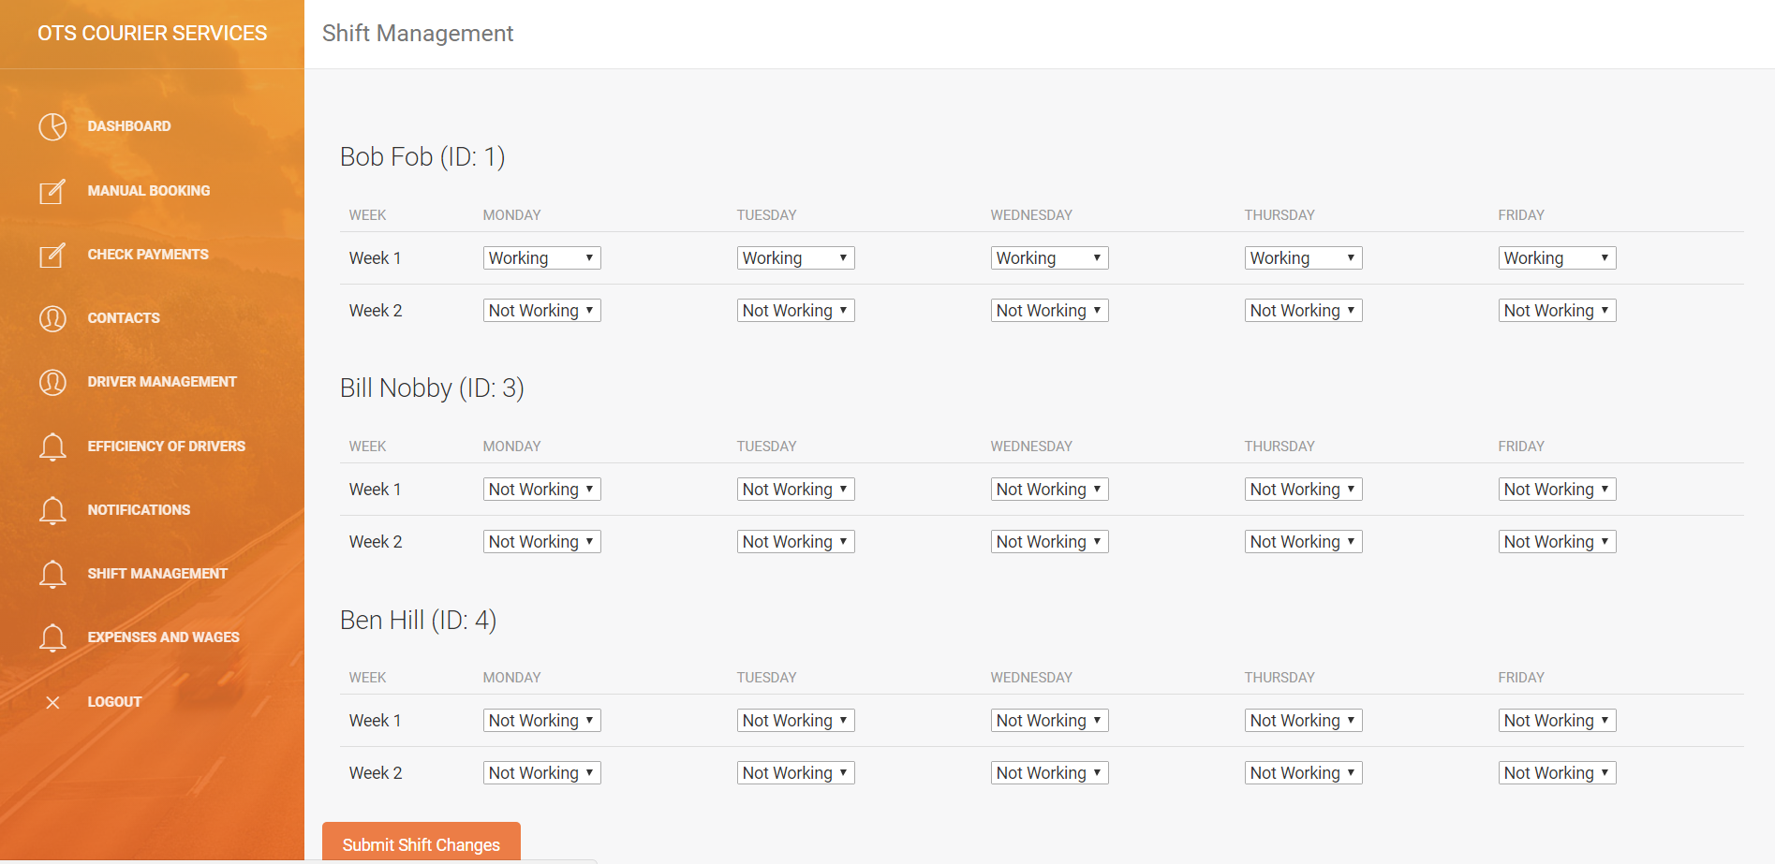

This screenshot shows the coordinator shift management portal. This is an addition that was made after consulting the client team about how shifts were too be assigned. This solution lets the coordinator change shifts for each day of the week for each person.